**Lynis Install**

Jayviar Laporte

**Table of Contents:**

Installing Lynis

Installing Lynis:

*Ubuntu-*

* 1) Installing Lynis is simple. We will use the git command to grab it from Github. Then using the link on Lynis’s website to install. The command for this will be:

Git clone <https://github.com/CISOfy/lynis.git>

*Successfully installed*

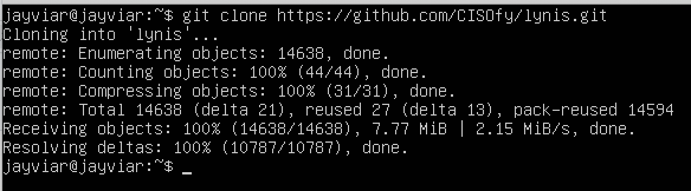

2) Next, in order to run Lynis, we must change into its newly installed directory. This can be done simply by running:

Cd lynis

*We can see its working as our command line name has changed*

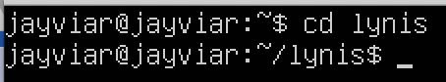

3) Now, lets run Lynis. For this lab, we will be running a scan on the host system We do this by running the command:

* ./lynis audit system
* * Below are a few screenshots from what the scan pulled:

*Lynis gives us some basic information about our system*

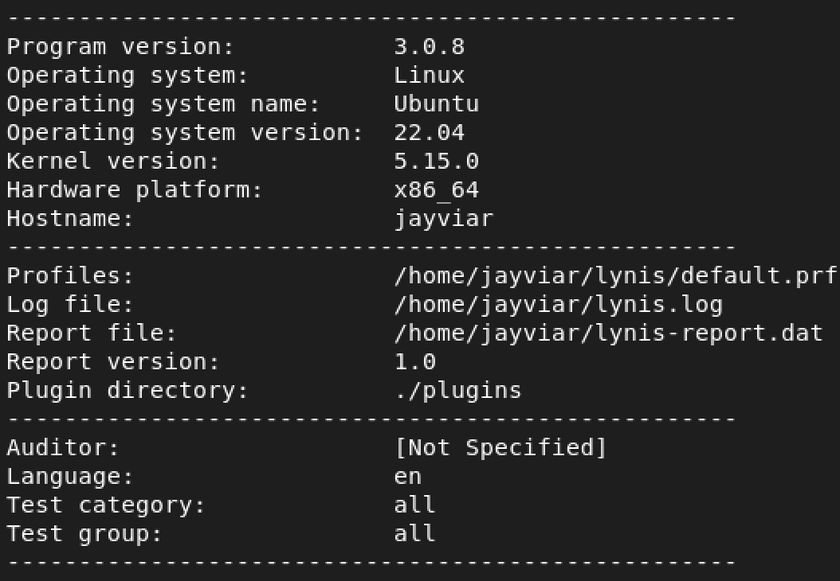

*Lynis displaying the status over a variety of different things such as file permissions*

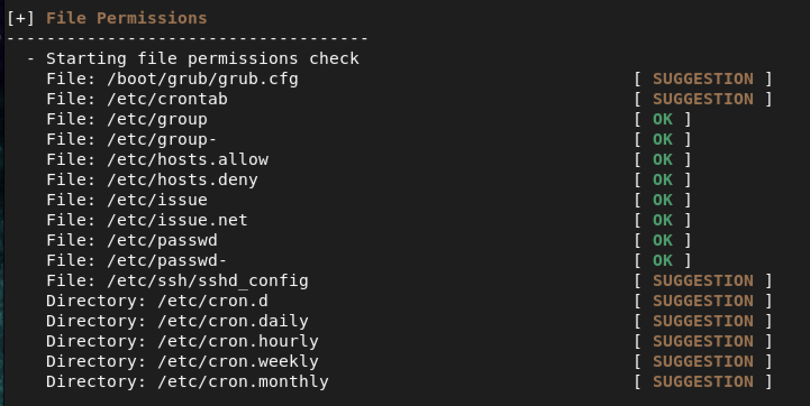

*Centos-*

1. Installing Lynis on our centos server is also relatively easy. All we need to do is just install it with the name specified. That would look as easy as this:

Sudo yum install lynis

*Here is what the finished installation will look like. Make sure to select “y” to allow it to download*

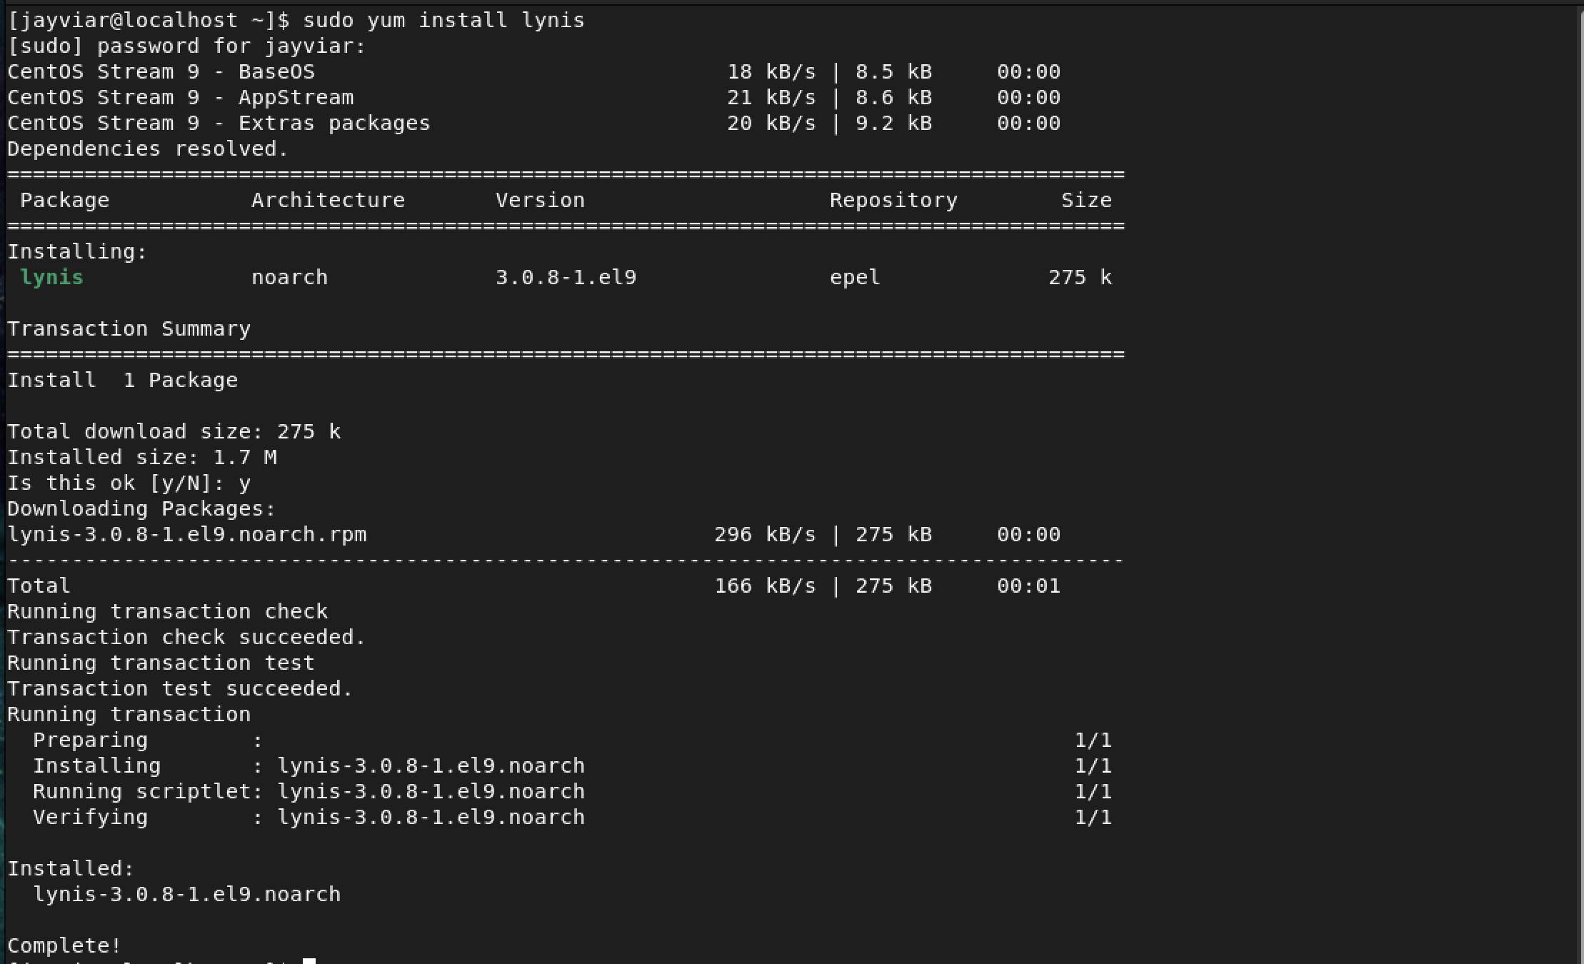

1. Now lets run lynis! We will be running an audit on the host system for this lab. The command will look like this:

Sudo lynis audit system

* * Below are a few screenshots from what the scan pulled:

*Lynis giving us info about our server*

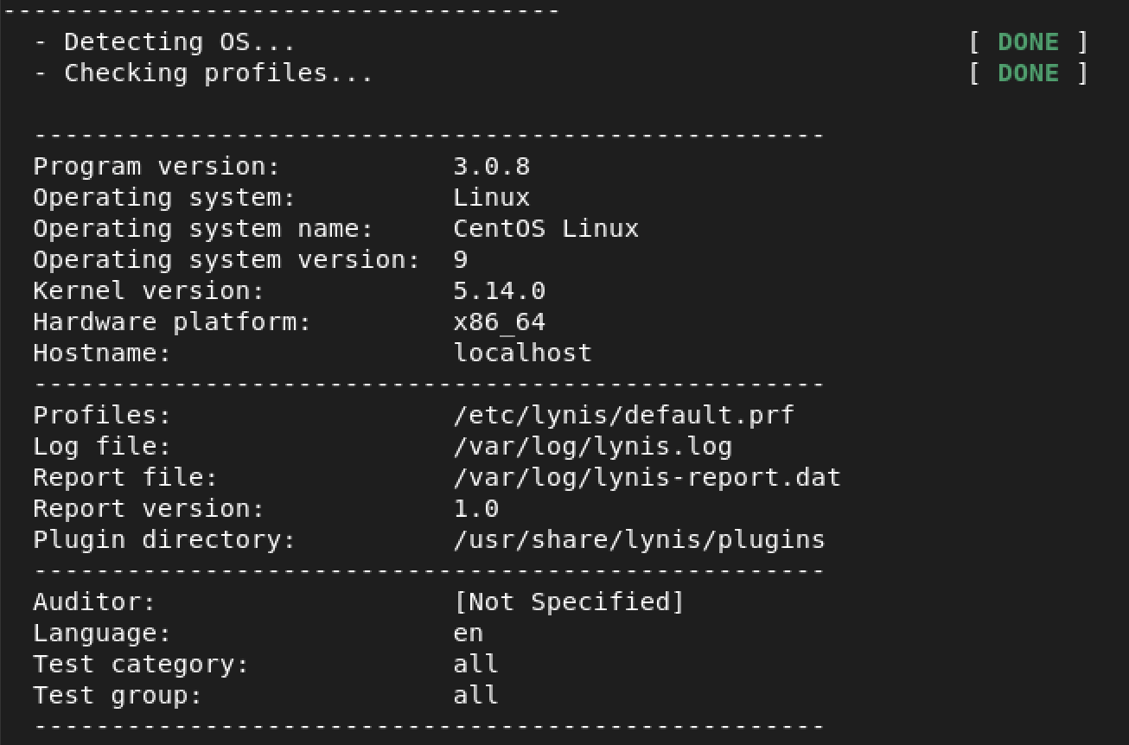

*Some of our boot and services being scanned as unsafe*

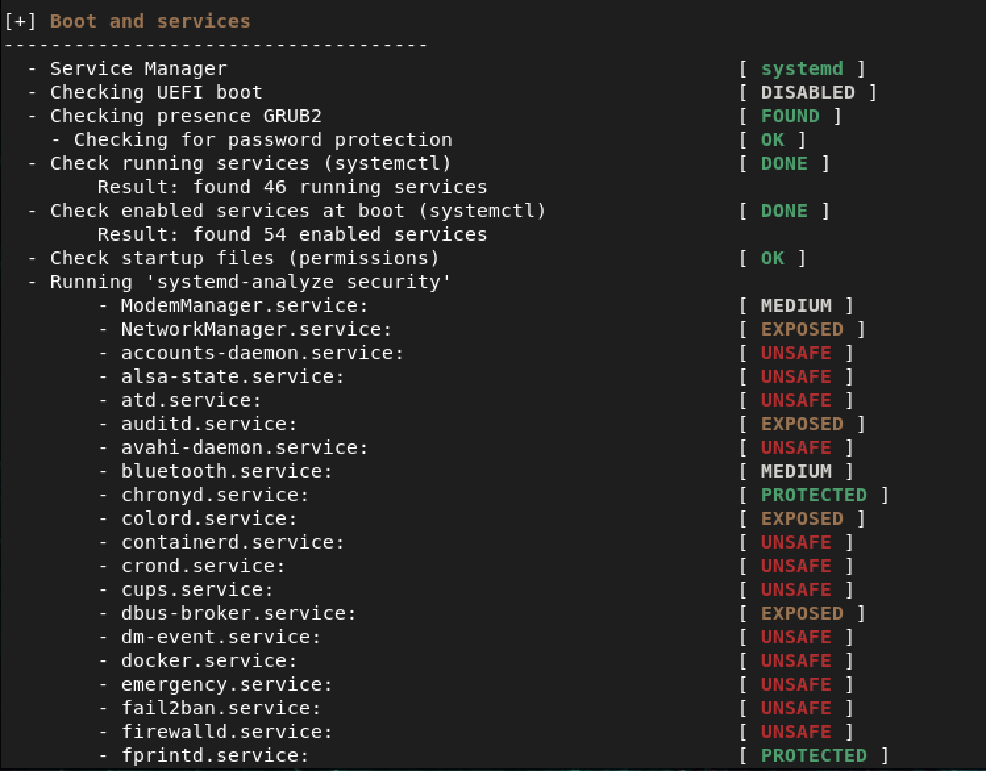

*File permissions being labeled as okay and suggestions*

